- Full code file (please drag and drop to explorer to make a copy):
- Screenshots:
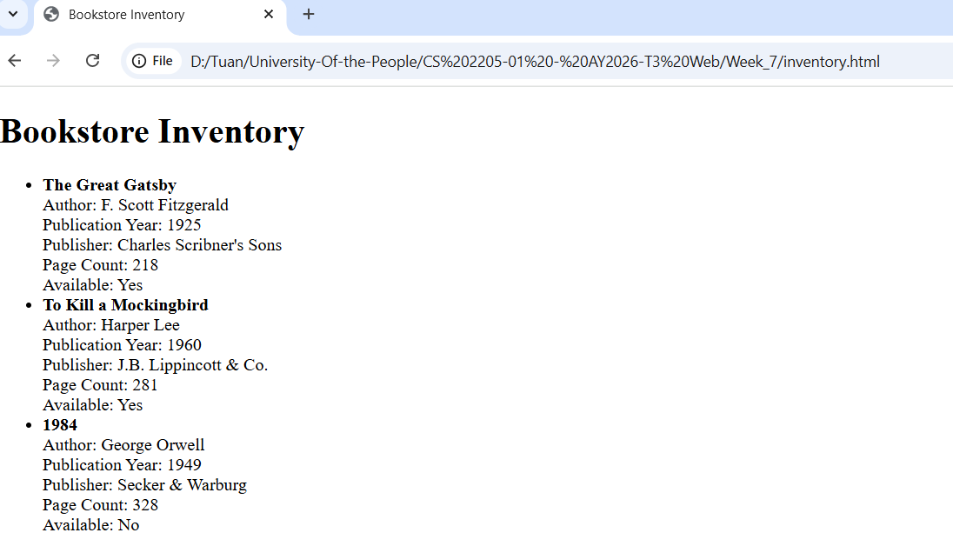
  - Here is the XML Schema code. This schema makes the catalog root element. Every book has id and available as attributes. The title element holds the book name as text and has publicationYear as a child element (integer). The author element has firstName and lastName. This structure matches all four required parts exactly and keeps data correct and easy to check.
<?xml version="1.0" encoding="UTF-8"?>
<xs:schema xmlns:xs="http://www.w3.org/2001/XMLSchema">
<xs:element name="catalog">
<xs:complexType>
<xs:sequence>
<xs:element name="book" maxOccurs="unbounded">
<xs:complexType>
<xs:sequence>
<xs:element name="title">
<xs:complexType mixed="true">
<xs:sequence>
<xs:element name="publicationYear" type="xs:integer" minOccurs="1" maxOccurs="1"/>
</xs:sequence>
</xs:complexType>
</xs:element>
<xs:element name="author">
<xs:complexType>
<xs:sequence>
<xs:element name="firstName" type="xs:string"/>
<xs:element name="lastName" type="xs:string"/>
</xs:sequence>
</xs:complexType>
</xs:element>
</xs:sequence>
<xs:attribute name="id" type="xs:string" use="required"/>
<xs:attribute name="available" type="xs:boolean" use="required"/>
</xs:complexType>
</xs:element>
</xs:sequence>
</xs:complexType>
</xs:element>
</xs:schema>

  - Here is the JSON data structure. It has an array of books with all four required parts and three real entries from the figure. When you open this HTML file in a browser, it shows the exact list from the figure. It reads the JSON and builds the bullets. This makes the output look the same and easy to update.
{
"books": [
{
"title": "The Great Gatsby",
"author": {
"firstName": "F. Scott",
"lastName": "Fitzgerald"
},
"publicationYear": 1925,
"details": {
"publisher": "Charles Scribner's Sons",
"pageCount": 218,
"available": true
}
},
{
"title": "To Kill a Mockingbird",
"author": {
"firstName": "Harper",
"lastName": "Lee"
},
"publicationYear": 1960,
"details": {
"publisher": "J.B. Lippincott & Co.",
"pageCount": 281,
"available": true
}
},
{
"title": "1984",
"author": {
"firstName": "George",
"lastName": "Orwell"
},
"publicationYear": 1949,
"details": {
"publisher": "Secker & Warburg",
"pageCount": 328,
"available": false
}
}
]
}
  - HTML file (contain Json above). The sript dynamically builds the bookstore inventory list on the webpage. It first finds the empty element with id="list", then loops through every book in the JSON data. For each book, it creates a new item and fills it with the book's title, author, year, publisher, page count, and availability status using template literals. Finally, it adds each to the list so the inventory appears exactly like the required figure without hard-coding the HTML.

<!DOCTYPE html>
<html lang="en">
<head>
<title>Bookstore Inventory</title>
</head>
<body>
<h1>Bookstore Inventory</h1>
<ul id="list"></ul>

<script>
const data = {
"books": [
{
"title": "The Great Gatsby",
"author": {
"firstName": "F. Scott",
"lastName": "Fitzgerald"
},
"publicationYear": 1925,
"details": {
"publisher": "Charles Scribner's Sons",
"pageCount": 218,
"available": true
}
},
{
"title": "To Kill a Mockingbird",
"author": {
"firstName": "Harper",
"lastName": "Lee"
},
"publicationYear": 1960,
"details": {
"publisher": "J.B. Lippincott & Co.",
"pageCount": 281,
"available": true
}
},
{
"title": "1984",
"author": {
"firstName": "George",
"lastName": "Orwell"
},
"publicationYear": 1949,
"details": {
"publisher": "Secker & Warburg",
"pageCount": 328,
"available": false
}
}
]
};

const ul = document.getElementById("list");
data.books.forEach(book => {
const li = document.createElement("li");
li.innerHTML = `
<strong>${book.title}</strong><br>
Author: ${book.author.firstName} ${book.author.lastName}<br>
Publication Year: ${book.publicationYear}<br>
Publisher: ${book.details.publisher}<br>
Page Count: ${book.details.pageCount}<br>
Available: ${book.details.available ? "Yes" : "No"}
`;
ul.appendChild(li);
});
</script>
</body>
</html>
3. Explain the importance of XML namespaces in the context of your online bookstore's data management: XML namespaces are important in our online bookstore because they keep data clean and safe.
The purpose of XML namespaces is to stop naming conflicts(AWS, n.d.). Many companies use the same tag name, for example "title". Without a namespace, the system does not know if it is a book title or a payment title. Namespaces add a special address (URI) so each name is unique.
They also help when we mix data from different XML vocabularies. Our bookstore can take book information from one supplier and sales data from another without mixing tags.
The syntax is easy. We write xmlns:prefix="http://example.com" in the root tag, like <catalog xmlns:book="http://ourstore.com">. Then we use the prefix: <book:title>.
One useful example in our bookstore is when we receive new book lists from publishers who use their own XML. Another example is sending order data to the bank system that uses different tags. Namespaces stop mistakes and make everything work together smoothly.
4. Compare and contrast the use of XML and JSON for data interchange in your online bookstore: XML and JSON are both good for moving data, but they have different strengths.
XML is strong because it uses a clear tree structure and XML Schema to check data (validation). It is good for complex catalog information. But XML is bigger (verbose) and slower. JSON is light, easy to read, and fast (AWS, n.d.; Joseph, 2018)
. Its weakness is less built-in validation.
XML is better for data storage inside our server where we need strict rules. JSON is better for sending data to the customer browser or mobile app because it is quick.
In JavaScript, JSON is very easy to use with JSON.parse and JSON.stringify. XML needs more code with DOM.
For example, we use XML to keep the full catalog with schema on the server. We use JSON to send the inventory list to the website page fast. This way, the bookstore application works well for both storage and quick customer views.

Reference
- AWS. (n.d.). What is XML? https://aws.amazon.com/what-is/xml/
- Joseph, D. B., & S, S. S. (2018). JavaScript and Json Essentials: Build light weight, scalable, and faster web applications with the power of Json. Packt Publishing, Limited. (Access through LIRN)
- MDN. (2024, June 28). XML Introduction. MDN Web Docs. https://developer.mozilla.org/en-US/docs/Web/XML/XML_introduction
- AWS. (n. d). What’s the difference between JSON and XML? https://aws.amazon.com/compare/the-difference-between-json-xml/

